# LAB 12 Practice

**Task 1**

**Task 3**

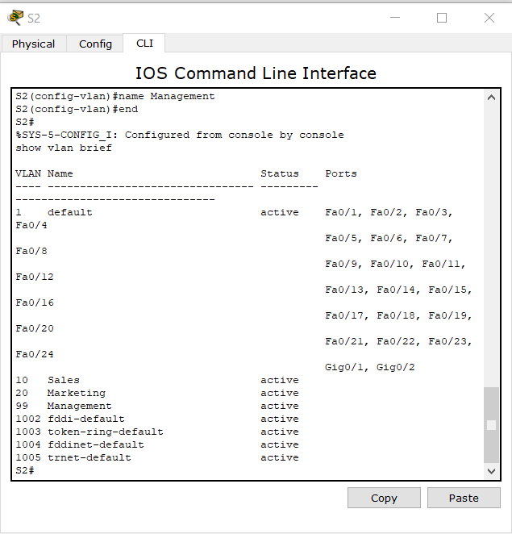

Switch 2 VLAN

Switch 3 VLAN

What ports are currently assigned to the three VLANs you have created?

* No ports has been assigned yet on the VLANs.

Trunk ports on switch 2

Trunk ports on switch 3

**Verify that the PCs can communicate. Ping several hosts from PC2.**

Ping from host PC2 to host PC5. Is the ping attempt successful?

* Yes

Because PC2 is in the same VLAN and the same subnet as PC5, the ping is successful

Ping from host PC2 to host PC1 (172.17.10.21). Is the ping attempt successful?

* No

Because these hosts are on different subnets and in different VLANs, they cannot communicate without a Layer 3 device to route between the separate subnetworks.

**Task 4**

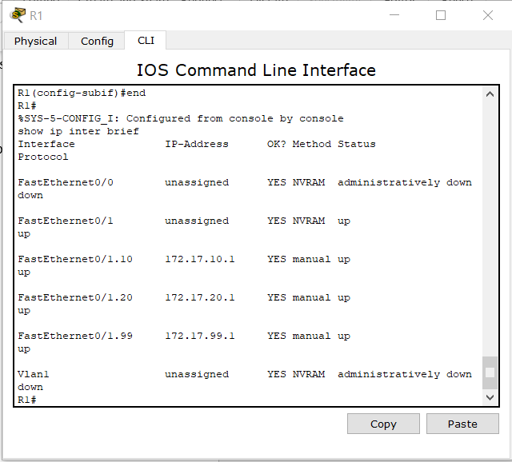

R1 IP configuration

R1 IP Route

**Verify Inter-VLAN routing**

PC1 pinging 172.17.50.254

PC1 pinging 172.17.20.22

PC1 pinging 172.17.10.24

Are the pings successful?

* Yes, all the pings are successful